

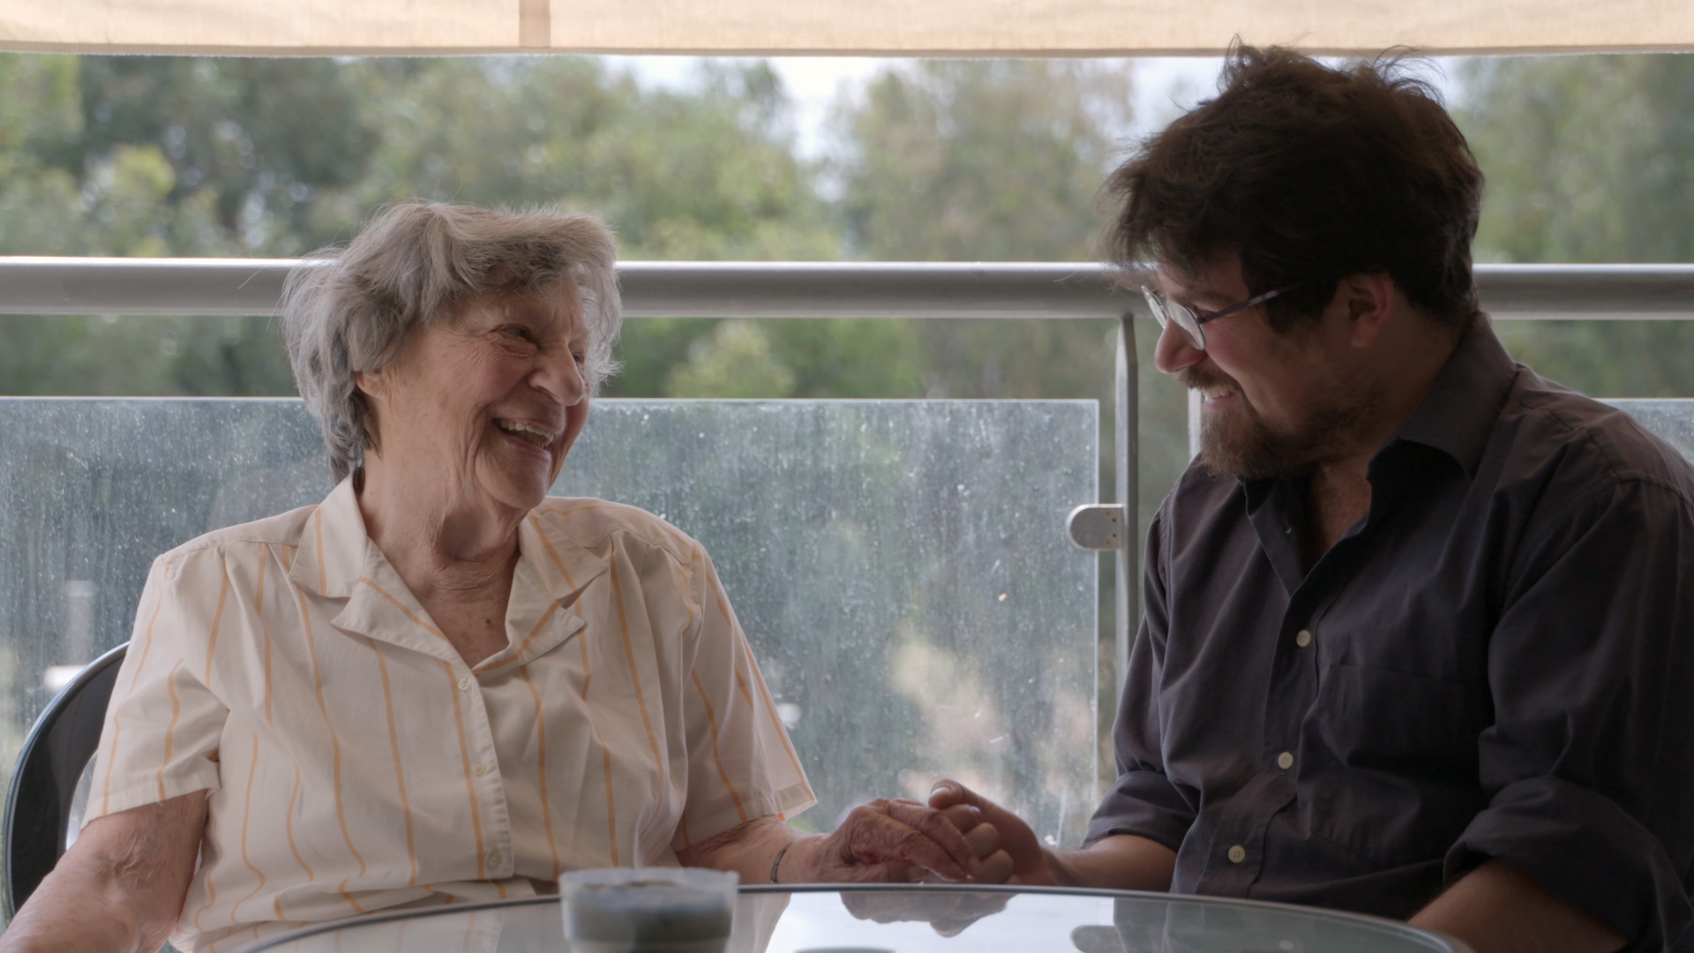

PRESS NOTES

BACK TO THE FATHERLAND

Directed & PRODUCED by: Kat Rohrer and Gil Levanon
Feature Documentary, 75 mins
WEBSITE: www.backtothefatherland.com

NEW YORK/ LOS ANGELES PUBLICITY CONTACT:
EMMA GRIFFITHS PR
E: emma@eg-pr.com
W: www.eg-pr.com

BACK TO THE FATHERLAND- Synopsis
Gil and Kat, both filmmakers, struck up a friendship during their time at college in New York City ten years ago. Gil comes from Israel, Kat from Austria. Their families' history is strikingly different. Gil is the granddaughter of a Holocaust survivor, Kat is one of a Nazi officer.
The exodus of many young secular Israelis to Germany and Austria prompt Gil and Kat to embark on a journey: to find other grandchildren of Holocaust survivors who had moved to Germany and Austria and learn how their grandparents reacted to that decision. Could returning to the site of their pain decades ago create reconciliation between generations?
BACK TO THE FATHERLAND follows the journey of three families in transition; Israeli grandchildren from the “Third Generation” and their respective grandparents. The film deals with both sides of the historic tragedy and the attempt to build their own future, without ignoring the past.

BACK TO THE FATHERLAND- CO- Directors Statement
Kat Rohrer
Just a short moment: A young man in his twenties, walks a German Shepherd dog on a Tel Aviv beach. When I see this type of dog the images that appear in my mind include: concentration camps, Nazi uniforms, Hitler himself. I grew up with substantial history lessons, with archive materials dealing with the Nazi era and with films like “Schindler’s List’ and “The Pianist.”

Now I can’t push the following questions out of my mind: How is it possible that a young Israeli owns a German shepherd dog? Why have young Israelis been emigrating to Germany and Austria in recent years, trying to build a future there? More likely than not, their families’ past is tightly interwoven with the Holocaust. How can anyone ignore history? Or am I asking the wrong questions?

Am I, a member of the “third generation” of the perpetrators, as aggrieved and burdened as my Israeli counterparts? How can this third generation, who were born of the families of victims, have a carefree life in Berlin or Vienna? What is their grandparents’ reaction to their grandchildren’s decision to live there of all places?

With those questions in mind and driven by a burning desire to learn more, I embarked on a unique journey with the help of my Israeli friends. I searched for contemporaries who had abandoned Israel to live in Germany or Austria.

During the process of making the film the protagonists shatter the fourth wall of the camera and Gil’s and my story became part of that journey. In the course of our research I realized the questions we were asking went beyond the Holocaust and the Israeli-Austrian/German conflict. I realized that the questions we were asking and the answers we were seeking are lessons that can be learned and applied to other conflicts, to other inter-generational traumas.

The disconnect between the generations in this globalized world is not unique to Israel, but the stakes are higher then for any other country. After their escape, and the construction the state of Israel, a younger generation feels increasingly alienated and pushed to the side. The film will give this ignored generation a voice. It will address a generational problem that hardly gets any attention in the media and hopes to help other 3rd generations to find their voice within their own family trauma.

Gil Levanon
Three years ago, when Kat came to visit me in Israel and wondered about the ‘movement’ of young Israelis moving to Germany and Austria and found myself intrigued. We have been spectators to this “phenomenon” for years, and I have quite a few friends and family members who have left Israel. I had the same questions as Kat.

Every time I have visited my sister in Berlin, I find myself confronted with the country’s Nazi past, always wondering how she lives with it. But of course of short visits you don’t bring these things up and rarely do you find the time to talk about such heavy topics.
When Kat asked me how my grandfather had felt about my sister’s move, I didn’t know, because I had never asked him. Partially because I was afraid of his answer. I know the two of them had discussed it and that he wasn’t happy with her decision.

The aftermath of war is being felt by the subsequent generations for decades. The grandchildren of the victims and perpetrators carry wounds that affect their lives. How do we live in the present, plan our future without letting the past hold us back? Are we willing to challenge our preconceived notions of the “other”? Can a Bosnian truly ever be friends with a Serbian? An Arminian and a Turk? An Austrian and an Israeli?
Many amazing people from different countries have worked on our film – Germans, Austrians and Israelis. All with different backgrounds, different family histories and national pasts. This project allowed all of us to start a dialogue about the past and our shared burden, which we as a third generation still carry. I believe we need each other to deal with these wounds, which were not inflicted on us directly, but on our families.
Due to Kat’s and mine totally different biographies, I hope we were able to give this story about exile and homeland a unique, unusual and interesting perspective, that resonates with audiences and their own experiences in our changing global world.

BACK TO THE FATHERLAND: FILMMAKER BIOGRAPHIES
Kat Rohrer (Director, Producer, Austria)
In 2002, Kat Rohrer founded her New York based production company,
GreenKat Productions. Since then Kat has directed and produced more the ten short films, music videos, documentaries, and a wide variety of industrials and commercials. Kat has also acted as DP on the feature length documentary “Larry Flint: The Right to Be Left Alone,” which screened world wide and was aired on IFC. Her last documentary “Fatal Promises,” which deals with human trafficking, has been shown across the US and Europe in film festivals, anti-trafficking and fundraising events and college campuses.

Gil Levanon (Co-Director, Co- Producer, Israel)
Gil Levanon has been writing, producing and directing award winning commercials, industrial and short films for over fifteen years. After completing her BFA in directing and graduating with honors from the School of Visual Arts in New York City, she associate produced in The Rolling Stones Show for MTV and later associate produced promos for USA Network ,and NBC. Her short film “Manfred” won second place in the Israeli Documentary Challenge Competition and screened in Cinematheques around Israel.

Anneliese Rohrer (Author, Producer, Austria)
Anneliese Rohrer has been a political journalist for over 30 years. As well as writing Op-ed pieces for international publications like The New York Times, The LA Times, amongst others, she was both the senior editor and head of the national affairs and the international affairs department at the Austrian daily newspaper Die Presse. She has been a senior commentator for CNN, BBC, ORF and PBS. She is the author of two books, including “Ende des Gehorsams” which was on the Austrian Bestseller List. She is the recipient of multiple awards, including an Award for Best Austrian Columnist and a Lifetime Achievement Award. She joined GreenKat Productions in 2004, to help with the production of “Fatal Promises” in the capacity of producer and interviewer, thus throwing a light on this very important subject matter of human trafficking.

Matthias Kress (Co-Producer, Germany)
Matthias Kress has over twenty years of experience in the film and theater industry. He started his career in theater in Germany and France, a passion he still pursues today. Matthias has also appeared on German and French television and film, including “Stratmanns”, “Sarah’s Key” and “Heiter bis tödlich.” Over the years, Matthias has developed a great passion for producing. He co-produced the German film “Before Tomorrow” / “Gegen Morgen”, which had it’s European premiere at the 2012 Berlinale.

Matthias is currently acting as a producer for GreenKat Productions in Germany on several documentary projects that are currently in development.

Susan Korda, (Co-Author, USA)
Susan Korda is a filmmaker who began her career as an editor on the Oscar-nominated documentary and Sundance-crowned For All Mankind.

She edited Sandi Du Bowski’s Trembling Before G-d where she is also credited as creative collaborator. She is story consultant on Alan Berliner’s The Sweetest Sound and First Cousin Once Removed. Korda is a producer of William Kunstler: Disturbing the Universe by Emily and Sarah Kunstler. Her own work includes the documentaries Vienna is Different and One of Us and the short narrative Salomea’s Nose. Korda taught at NYU’s Tisch School of the Arts from 1996-2006, and was a Visiting Artist at Cooper Union in 2004. In Europe she has lectured at the international film school, Cologne; Binger Film Lab, Amsterdam and University of Applied Science, Vienna. She guest lectures at the Edinburgh College of Arts and the Sam Spiegel School in Jerusalem. She’s currently developing further projects in Berlin and New York and works as a story and editorial consultant.

Thomas Marschall (DIRECTOR OF PHOTOGRAPHY)
Thomas Marschall studied Cultural and Visual Anthropology at the University of Vienna. From 2002 to 2009, he continued his studies of film, cinematography and screenplay writing at the Academy for Cinema and Television, University of Performing Arts Vienna. Since 2008, Thomas has shot and also directed several documentary project, which have been supported by the BUKK and have aired on 3SAT, ORF, ARTE and several other television stations. His films have screened internationally at festivals.

He has also been the DOP on national and international commercials for TV, some of his clients include Vodafone UK, Kraft Foods.

Since 2010 Tom has also been very involved in a vast array of cross-over projects in the areas of film, visual art, and science. “Back to the Fatherland” marks the second collaboration with GreenKat Productions and Kat Rohrer, previously shooting their documentary “Fatal Promises.”

ABOUT FIRST RUN FEATURES
First Run Features was founded in 1979 by a group of filmmakers to advance the distribution of independent film. First Run quickly gained a reputation for its controversial catalog of daring documentaries and fiction films. Today First Run remains one of the largest independent distributors in North America, releasing in theaters nationwide; to schools, libraries and other educational institutions; on home video on DVD and Blu-Ray; to television broadcasters; and online through a diverse group of innovative digital partners. Recent releases include "Moynihan," "Stefan Zweig: Farewell to Europe," "Chasing Portraits," and "Germans & Jews."
The First Run legacy includes films by such notable directors as Spike Lee, Michael Apted, Peter Jackson, Alex Gibney, Joe Berlinger, Allen Miller, Rose Troche, Sven Nykvist, Jane Campion, Ross McElwee, Michael Winterbottom, DA Pennebaker and Chris Hegedus, Barbara Kopple, Dariush Mehrjui, David O. Russell, Lizzie Borden, Michael Verhoeven, Claude Chabrol, Jan Svankmajer, Claire Denis, Benoit Jacquot, Marleen Gorris, Radley Metzger, Mark Kitchell, Deborah Shaffer, Victor Nunez, The Brothers Quay, George Sluizer, Monika Treut and Satyajit Ray.
Check out our website: www.firstrunfeatures.com

BACK TO THE FATHERLAND- CREW
PRODUCTION | GreenKat Productions
PRODUCER/ DIRECTOR | Kat Rohrer
WRITER | Anneliese Rohrer
CO-DIRECTOR /  CO-PRODUCER (ISRAEL) | Gil Levanon
LINE PRODUCER | Janine Michtner
POST-PRODUCTION ASSISTANT | Julian Matzat
WRITER | Susan Korda
CO-PRODUCER (GERMANY) | Matthias Kress
DP | Tom Marschall
ADD‘ CAMERA (ISRAEL) * | Ofer Barr  Israel
ADD‘ CAMERA (ISRAEL) * | Kristina Vasylyeva  Israel
ADD‘ CAMERA (GERMANY) * | Ashton Green  Berlin
EDITOR | Georg Eggenfellner
ASSISTANT EDITOR | Dor Harel
SOUND MIXING / EDITING | Andreas Pils Tonstudio
AFTER EFFECTS | Markus Cermak
COMPOSER | Tao Zervas
GRAPHIC DESIGN | Shani Avni
POST PRODUCTION | Christian Leiss Post Production  GMBH
COLOR CORRECTION | Christian Leiss

BACK TO THE FATHERLAND- CAST
Lea Ron Peled
Gidi Peled
Dan Peled
Uri Ben Rehav
Guy Shahar
Katharina Maschek
Kat Rohrer
Gil Levanon
Yochanan Tenzer
Ayelet Triest
Efrat Bar-Akiva
David Levi
Hamutal Peled
Shir Levanon
Yehoram Davidi
Inbal Lori
Omer Koren
Anat Raban
Asaf Ben-Hur
Hannah Becke

